**SMALLEST NUMBER IN AN ARRAY**  
  
**EXP NO: 11**  
**AIM:**To find the smallest number from an array using 8085 processor.  
  
**ALGORITHM:**  
  
1)      Load the address of the first element of the array in HL pair.  
  
2)      Move the count to B register.  
  
3)      Increment the pointer.  
  
4)      Get the first data in A register.  
  
5)      Decrement the count.  
  
6)      Increment the pointer.  
  
7)      Compare the content of memory addressed by HL pair with that  
of A register.  
  
8)      If carry=1, go to step 10 or if carry=0 go to step 9  
  
9)      Move the content of memory addressed by HL to A register.  
  
10)  Decrement the count.  
  
  
 **PROGRAM:**  
  
 LXI H,2050  
 MOV C,M  
 DCR C  
 INX H  
 MOV A,M  
 LOOP1: INX H  
 CMP M  
 JC LOOP  
 MOV A,M  
 LOOP: DCR C  
 JNZ LOOP1  
 STA 2058  
 HLT  
  
  
   
  
  
**INPUT:**  
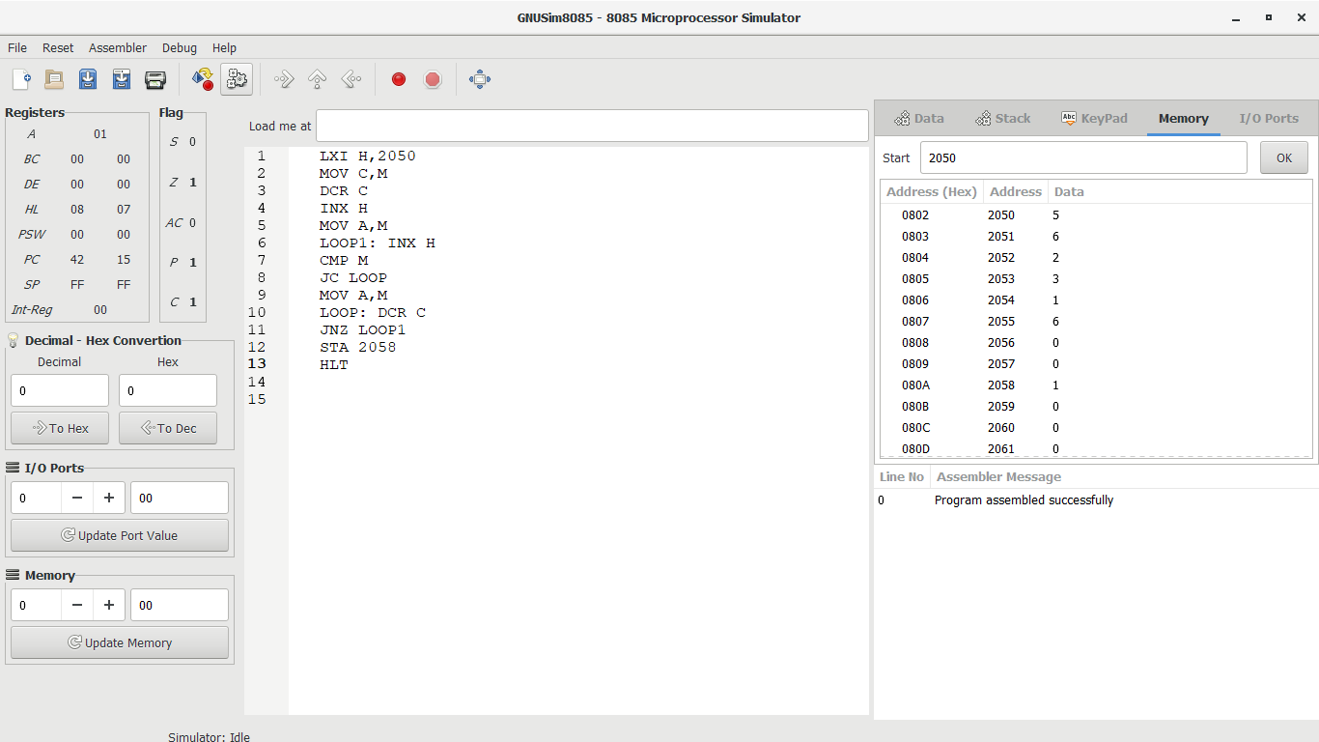  
  
   
  
  
   
  
  
**OUTPUT:**  
  
  
 

**RESULT:**

Thus the program was executed successfully using 8085  
processor simulator.